# CIS 641 01 - IP - Systems Analysis and Design (F24) IC2 - Use Case Diagrams + Activity Diagrams

1. **Activity Diagram 1: To add new application and new password**

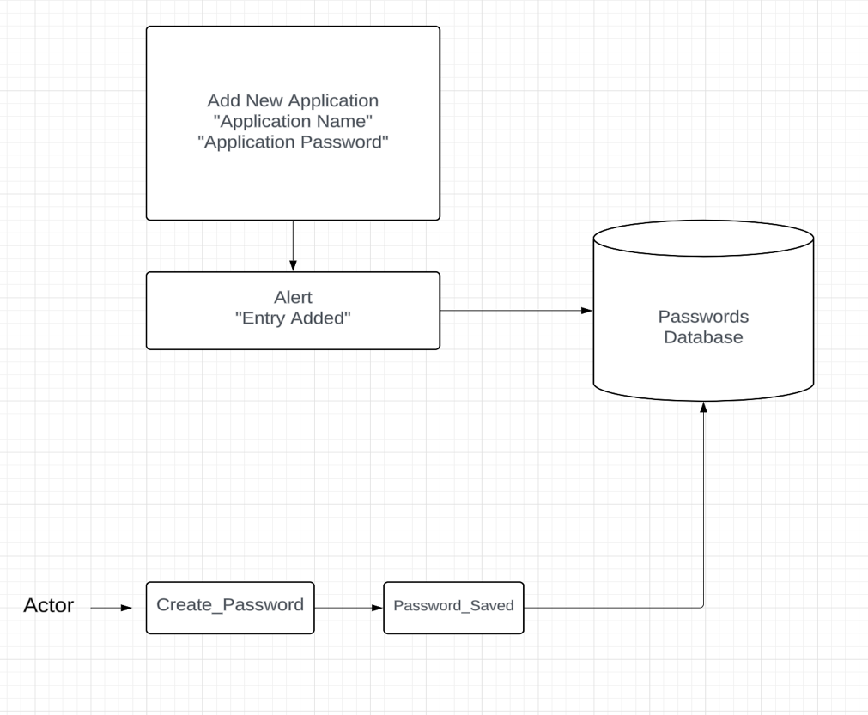

1. **Activity Diagram 2: To view the saved password**

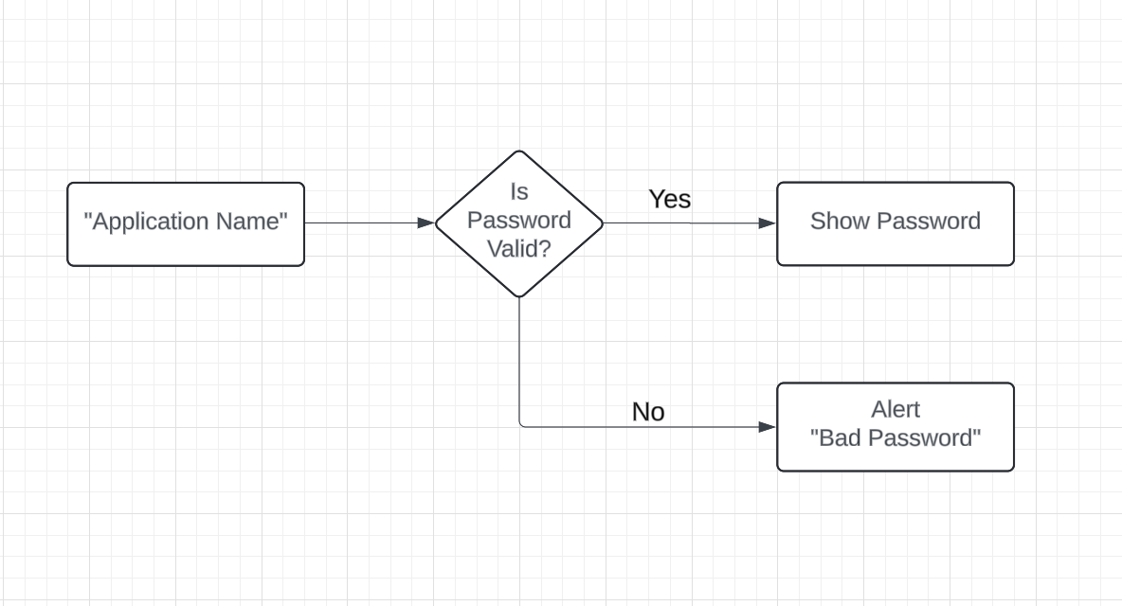

# 2 Use Case Diagrams

1. **Use Case Diagram 1: To add new application and new password**

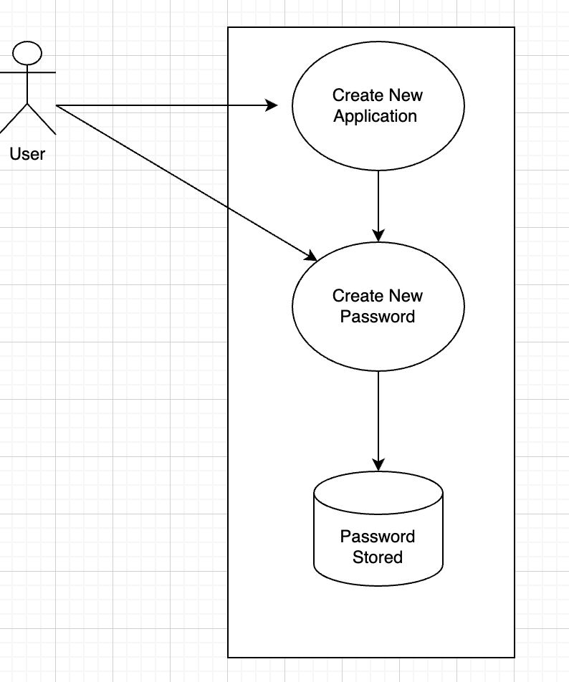

1. **Use Case Diagram 2: To generate a random password.**

